**Network Administration Report**

**Table of Contents**

1. Executive Summary
2. Introduction
3. Network Devices Information
   * Windows 11 (10.0.2.6)
   * Linux Server 1 - Ubuntu (10.0.2.15)
   * Kali Linux (10.0.2.8)
4. Information Collection Methodology
5. Network Topology Diagram and Segmentation Recommendations
6. References and Citation

**1. Executive Summary**

This report provides an overview of the network devices in our lab environment, focusing on data collected using Nmap and Wireshark. We detail device-specific information, data collection methodologies, and recommendations for enhancing security through network segmentation. Our approach involved initial setup, network scanning using Nmap and Zenmap, data verification, and thorough traffic analysis using Wireshark. By following these steps, we ensure accurate documentation of our network devices, laying the groundwork for improved security.

**2. Introduction**

This report documents the network devices in the lab environment, detailing the information collected using Nmap and Wireshark. The report includes device-specific information, the methodologies used for data collection, and recommendations for network segmentation to enhance security.

**3. Network Devices Information**

**Windows 11 (10.0.2.6)**

* **Device Host Name**: windows11-deskt
* **IP Address**: 10.0.2.6
* **MAC Address**: 08:00:27: CB:20:4A (Oracle VirtualBox virtual NIC)
* **Operating System & Version**: Microsoft Windows 11 Home - Version 10.0.22631 N/A Build 22631
* **Open Ports with Associated Services**:
  + 80/tcp open http (PRTG)
* **ARP Ping Scan Elapsed Time**: 0.00076s
* **OSI Layer Information**:
  + **IP Address**: Layer 3 (Network Layer)
  + **MAC Address**: Layer 2 (Data Link Layer)
  + **Port Numbers**: Layer 4 (Transport Layer)
* **Wireshark & Zenmap Screen Captures**:

Zenmap intense scan from Kali Linux (10.0.2.8) to Windows 11 (10.0.2.6)

* 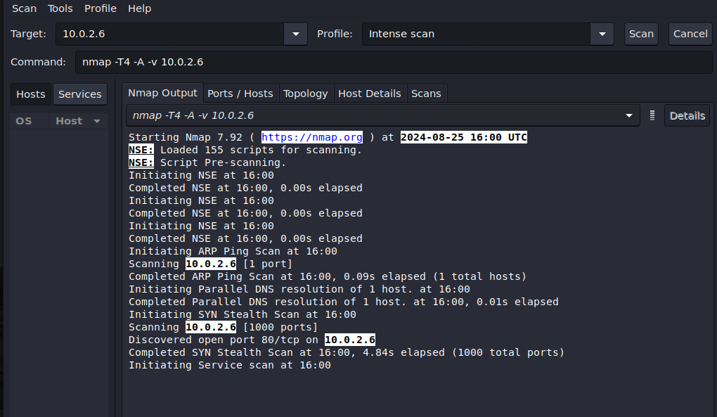

Discovered open port 80/tcp on 10.0.2.6

* 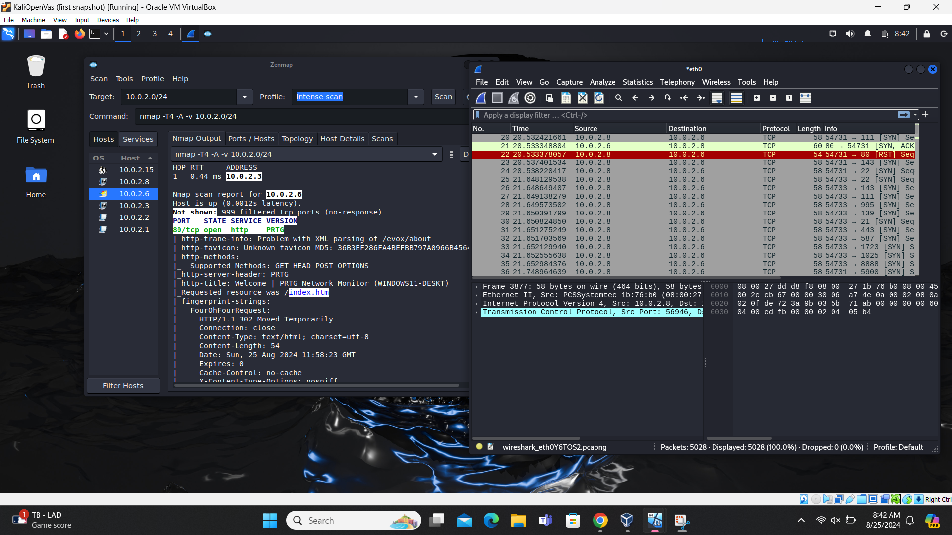

Zenmap shows open port80/tcp using http & Wireshark shows anomaly with TCP- RST

* 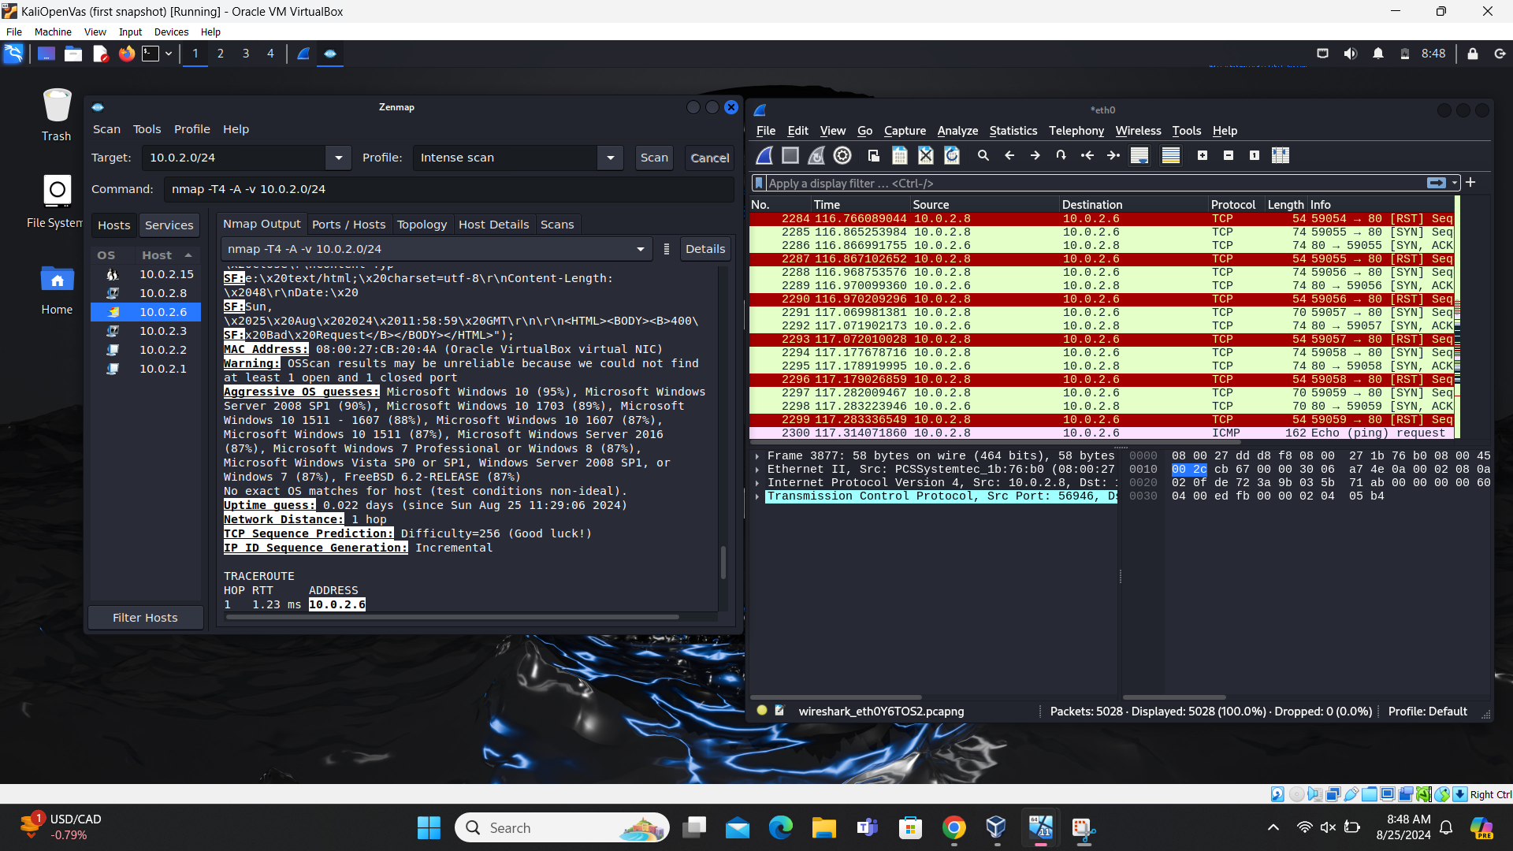

Shows Zenmap scan results for open port & MAC address

* 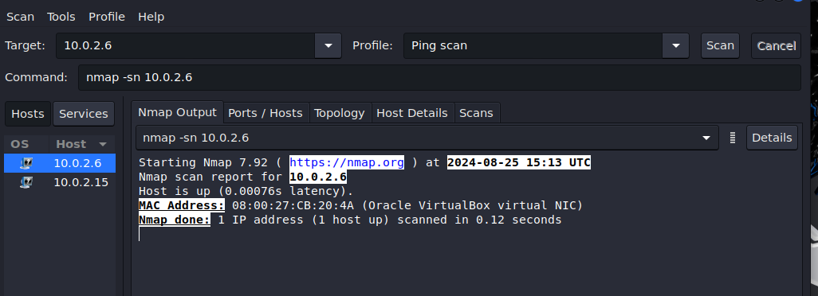

Zenmap scan done output, host is up with latency resembles ARP ping scan elapse time

* 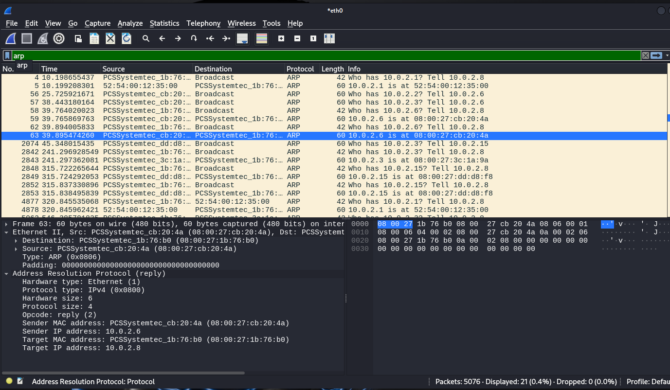

ARP routing of IP address to MAC address, IPv4 protocol used, Sender & Target IP/MAC address

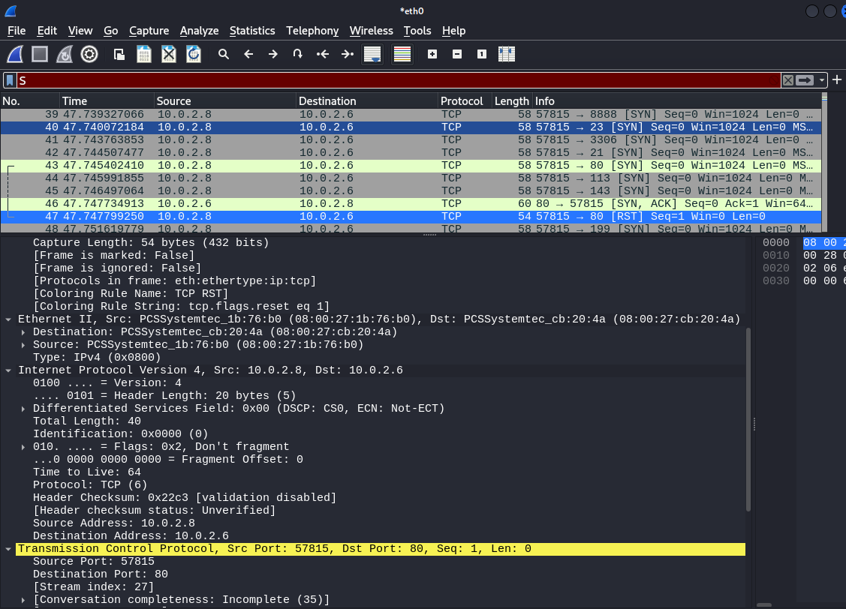

3-way handshake of TCP with source & destination ports, TTL (time to live), details on Ethernet II ( Data layer)-IPv4 (Network layer) & TCP ( Transport Layer)

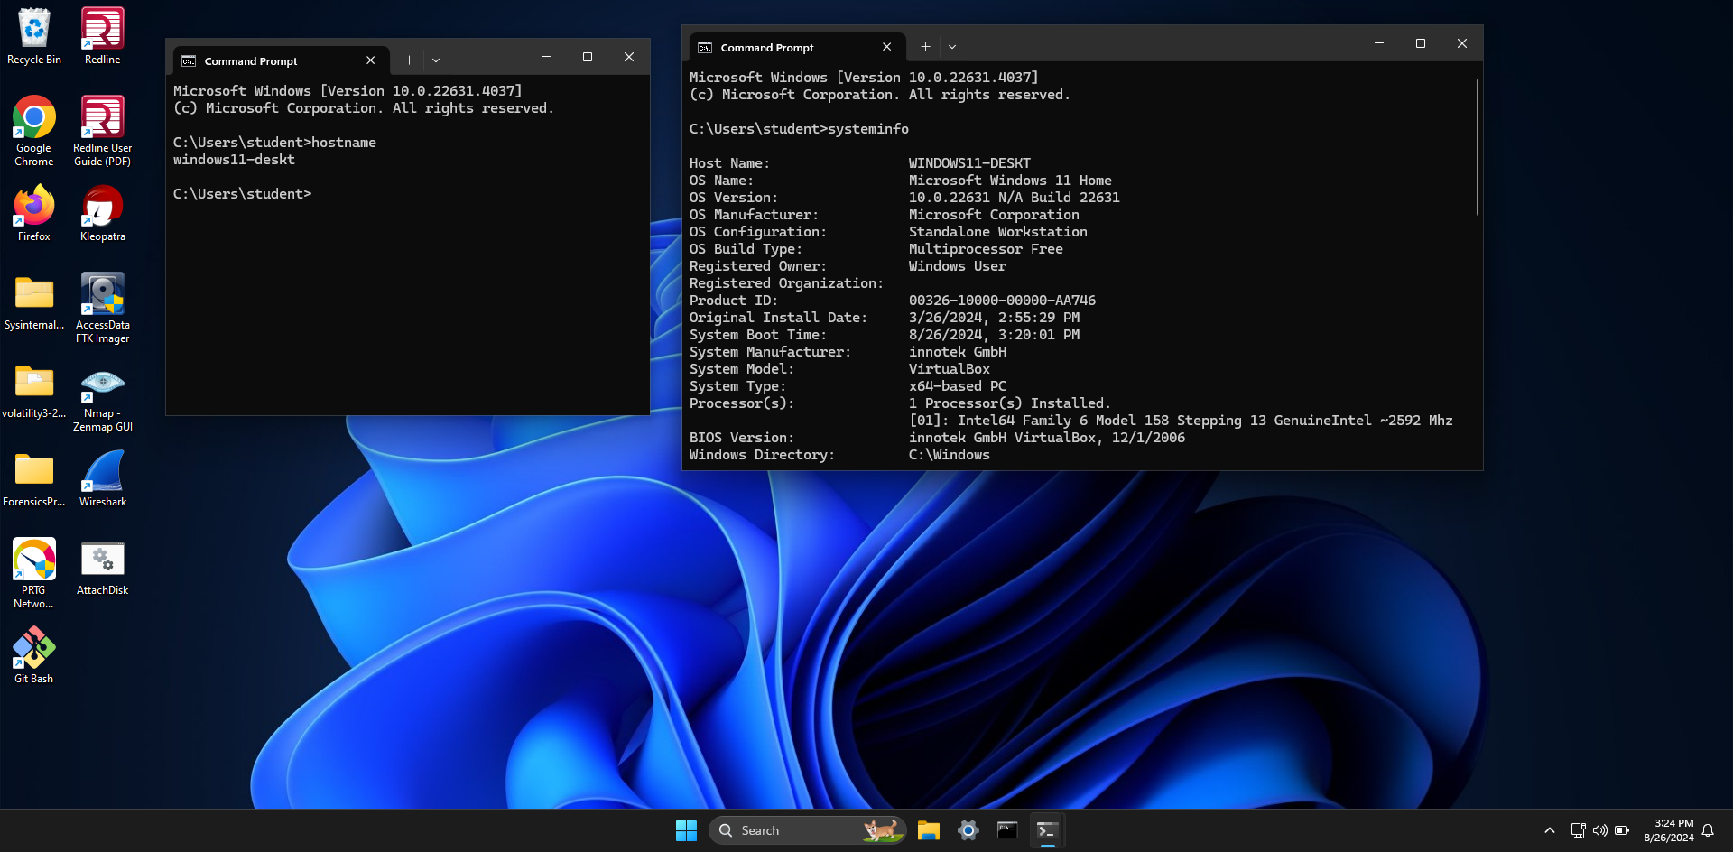

Host Device Name & OS Name/Version

**Linux Server 1 - Ubuntu (10.0.2.15)**

* **Device Host Name**: linux-server
* **IP Address**: 10.0.2.15
* **MAC Address**: 08:00:27:DD:D8:F8 (Oracle VirtualBox virtual NIC)
* **Operating System & Version**: Linux 4.15 - 5.6, Linux 5.0 - 5.4
* **Open Ports with Associated Services**:
  + 3306/tcp open mysql (MySQL 8.0.37-0ubuntu0.22.04.3)
* **ARP Ping Scan Elapsed Time**: 0.00074s
* **OSI Layer Information**:
  + **IP Address**: Layer 3 (Network Layer)
  + **MAC Address**: Layer 2 (Data Link Layer)
  + **Port Numbers**: Layer 4 (Transport Layer)
* **Wireshark & Zenmap Screen Captures**:

Zenmap intense scan from Kali Linux ( 10.0.2.8) to Linux Server 1-Ubuntu ( 10.0.2.15)

* 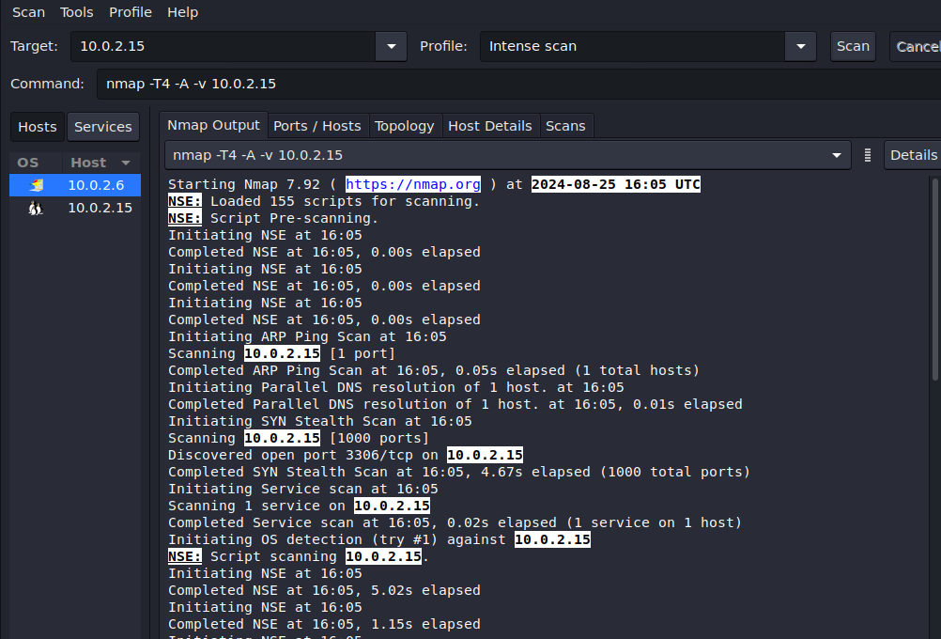

Discovered open port 3306/tcp on 10.0.2.15

* 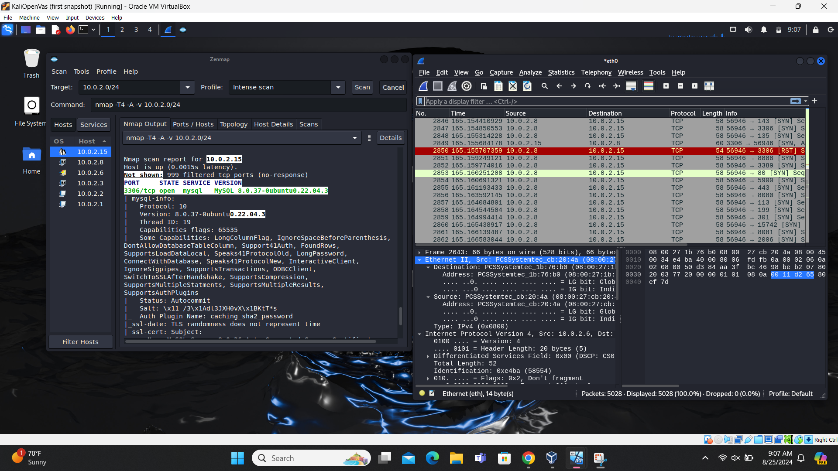

Zenmap shows open port 3306/tcp using mysql & Wireshark shows anomaly with TCP- RST

* 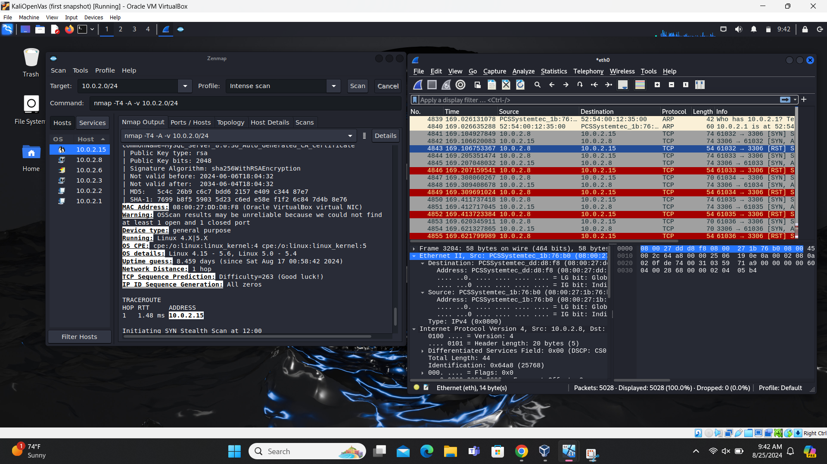

Shows Zenmap scan results for open port & MAC address, OS type & version

* 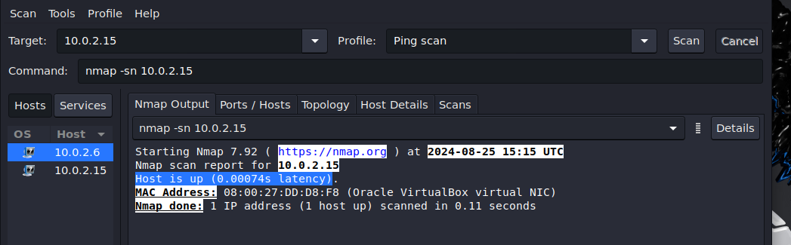

Zenmap scan done output, host is up with latency resembles ARP ping scan elapse time

* 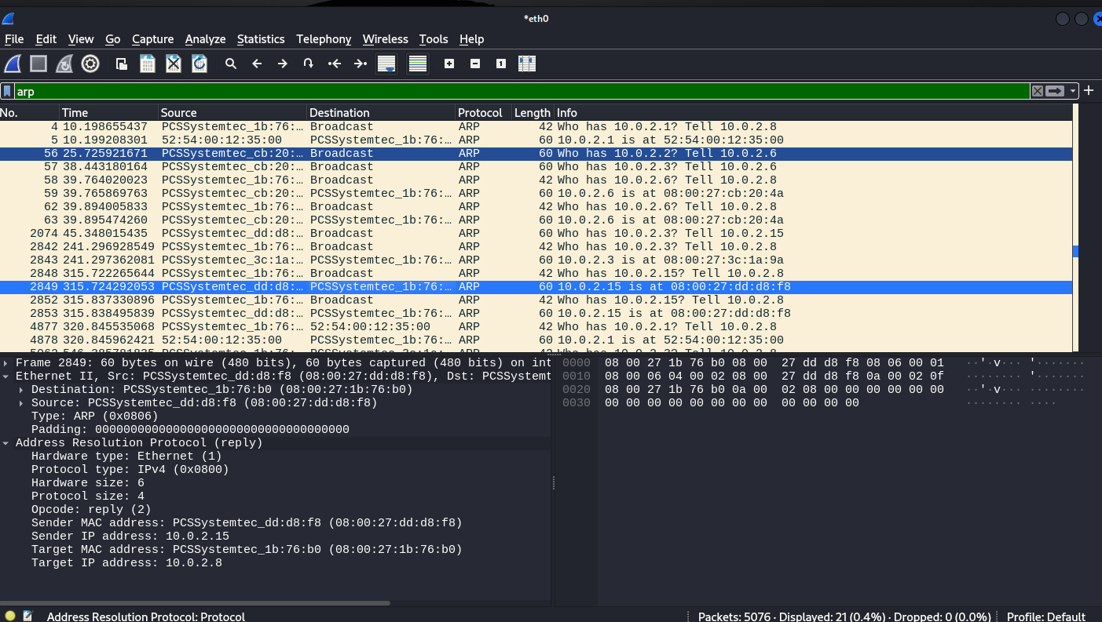

ARP routing of IP address to MAC address, IPv4 protocol used, Sender & Target IP/MAC address

* 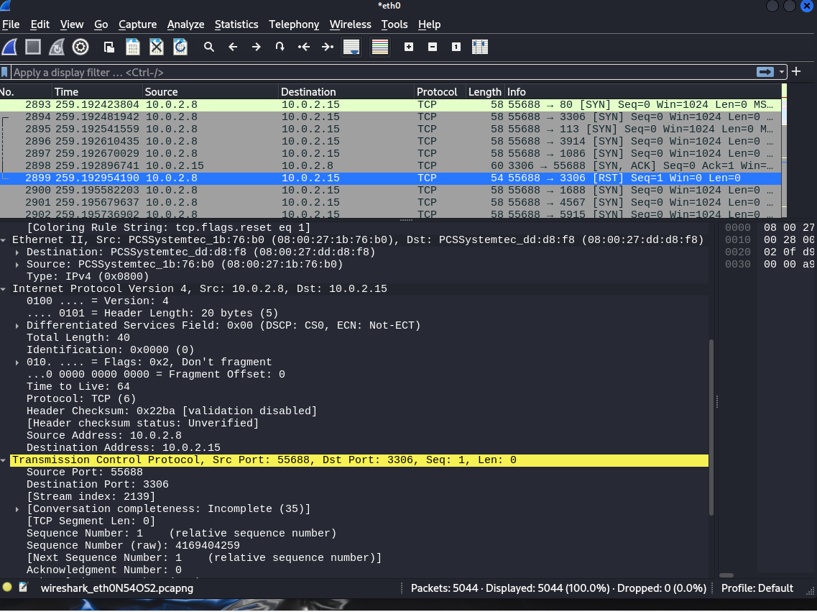

3-way handshake of TCP with source & destination ports, TTL (time to live), details on Ethernet II ( Data layer)-IPv4 (Network layer) & TCP ( Transport Layer)

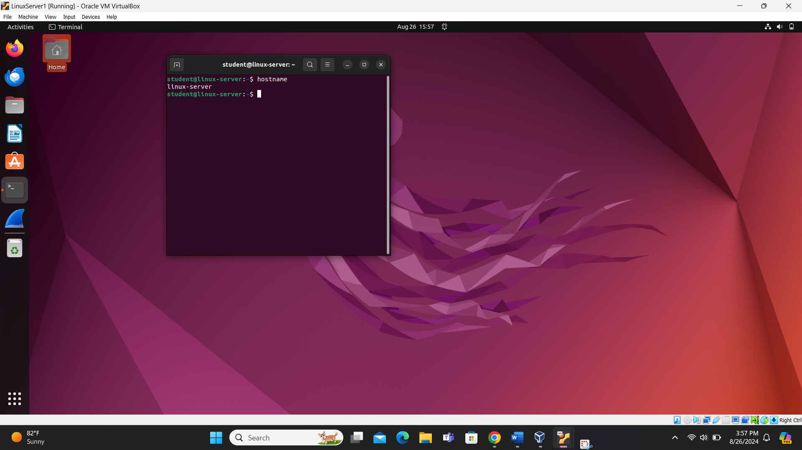

Host Device Name

**Kali Linux (10.0.2.8)**

* **Device Host Name**: kali
* **IP Address**: 10.0.2.8
* **MAC Address**: 08:00:27:1b:76:b0
* **Operating System & Version**: Too many fingerprints match this host to give specific OS details
* **Open Ports with Associated Services**: None (all 1000 ports scanned are closed)
* **ARP Ping Scan Elapsed Time**: Host is up (0.000043s latency)
* **OSI Layer Information**:
  + **IP Address**: Layer 3 (Network Layer)
  + **MAC Address**: Layer 2 (Data Link Layer)
  + **Port Numbers**: N/A (No open ports)
* **Wireshark & Zenmap Screen Captures**:

Zenmap intense scan from Kali Linux (10.0.2.8) to Kali Linux ( 10.0.2.8)

* 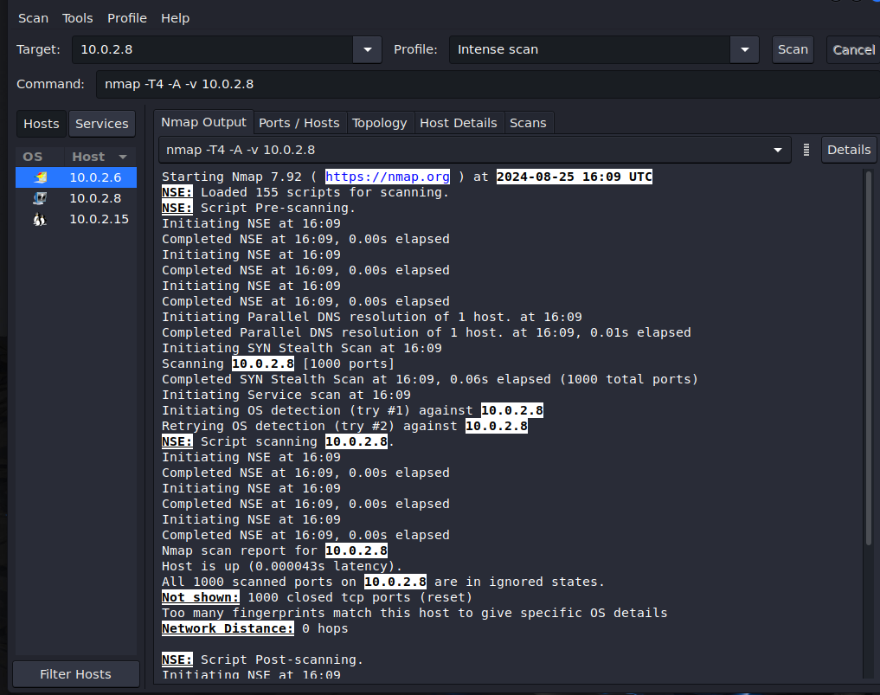

all 1000 ports scanned are closed & OS & version information

* 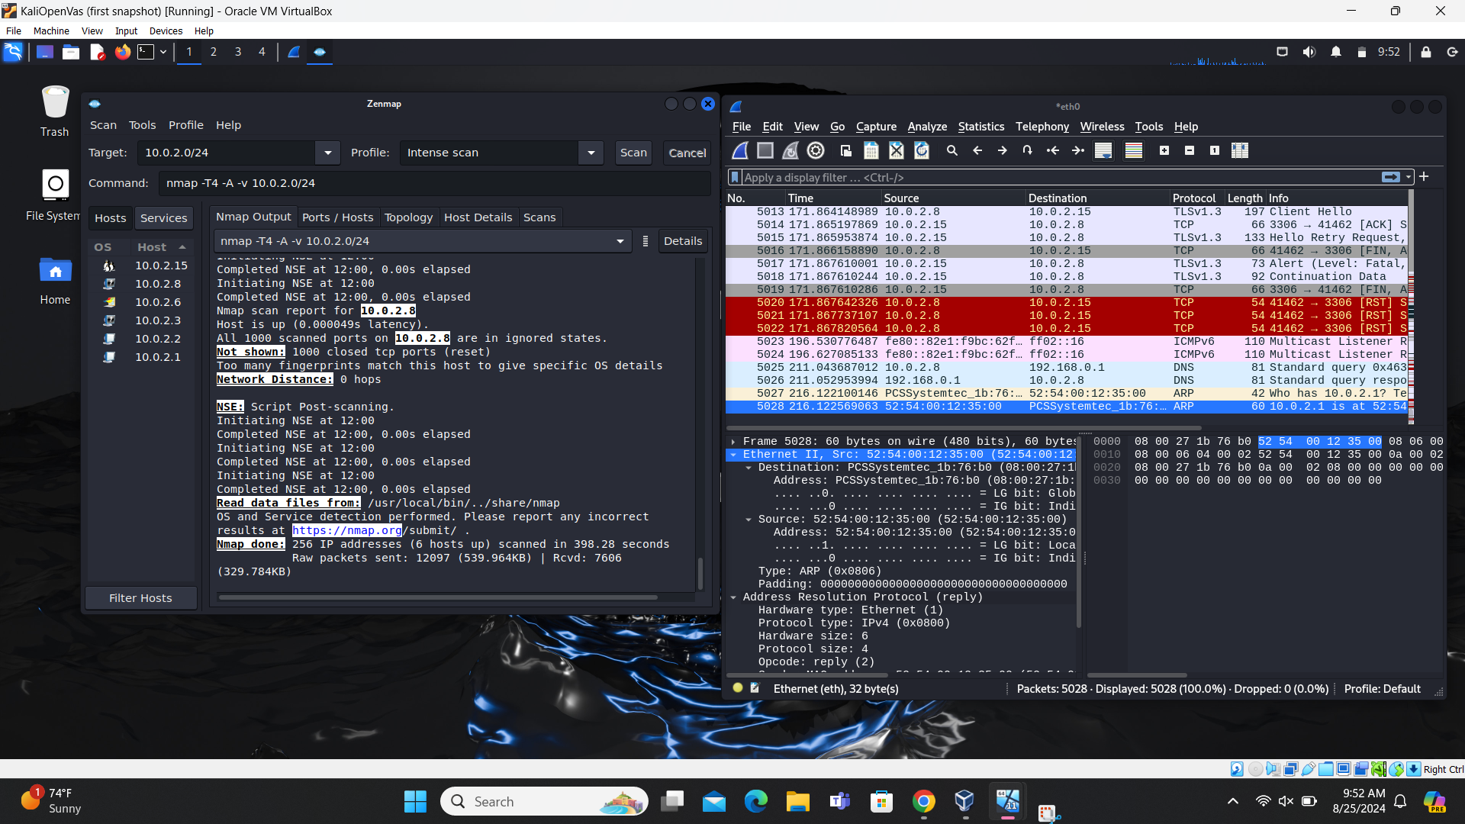

Zenmap scan done output, host is up with latency resembles ARP ping scan elapse time (please disregard Wireshark image from other VM scan)

* 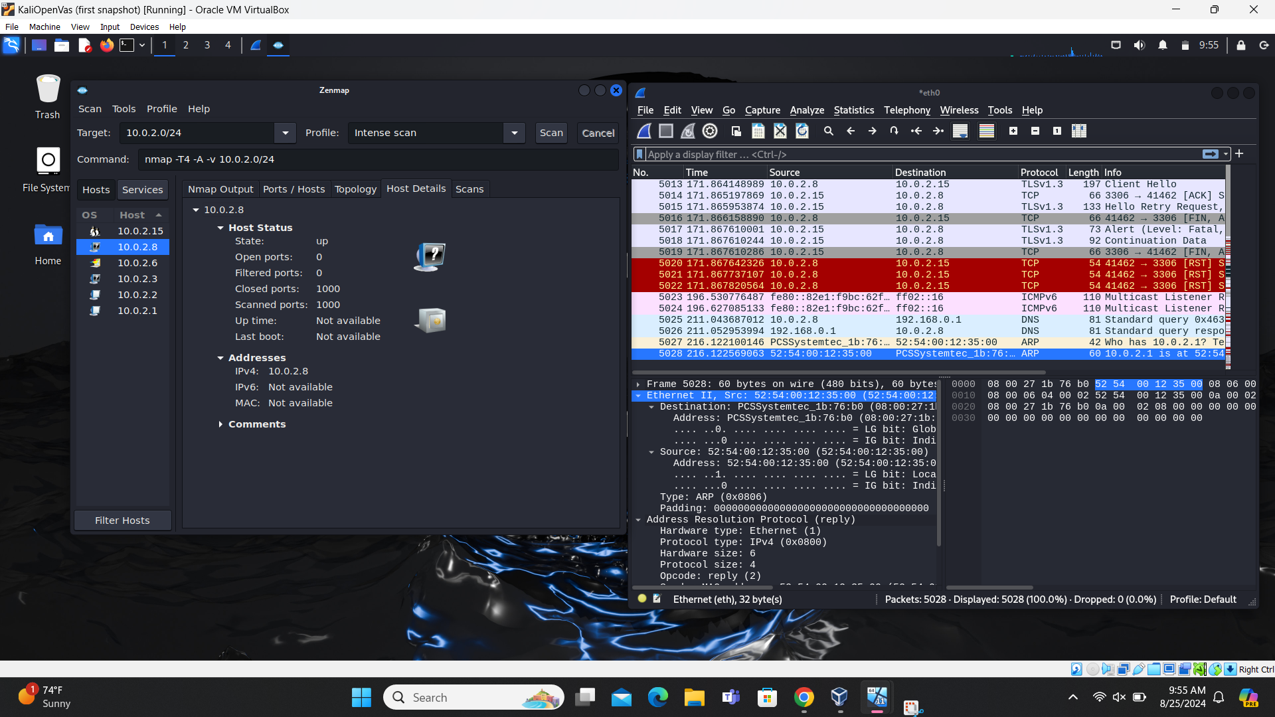

Zenmap scan Ports/Hosts status (please disregard Wireshark image from other VM scan)

* 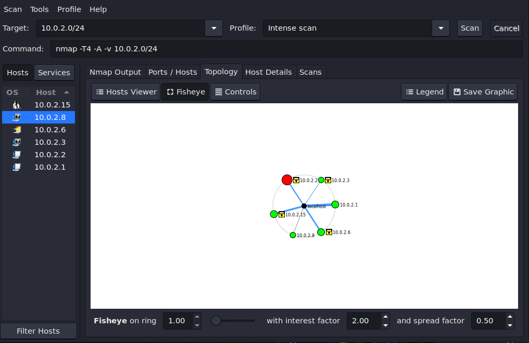

Network Topology diagram after Zenmap scan on entire 10.0.2.0/24 network ( star topology)

* 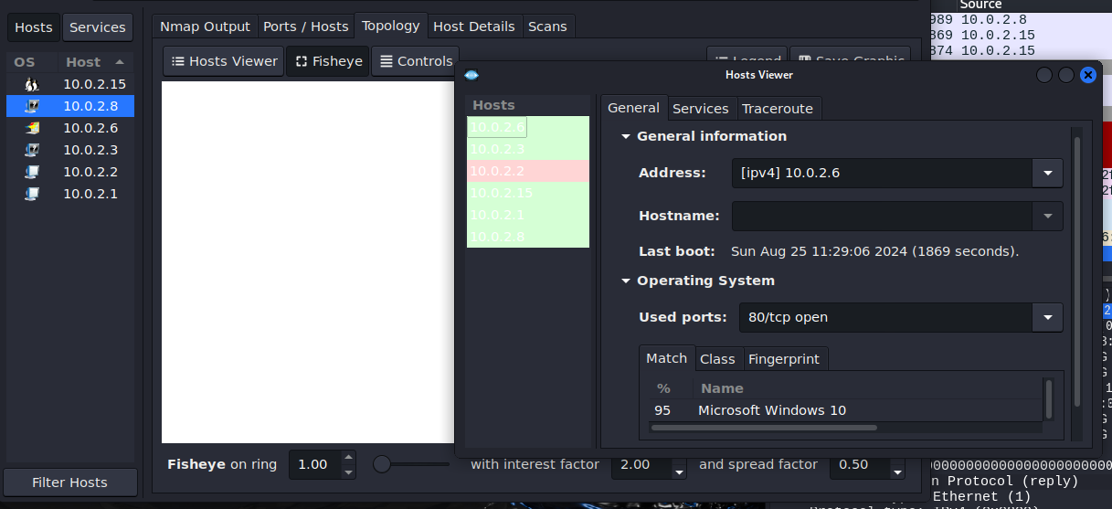

Zenmap scan-Host Viewer details of Windows VM with used port

* 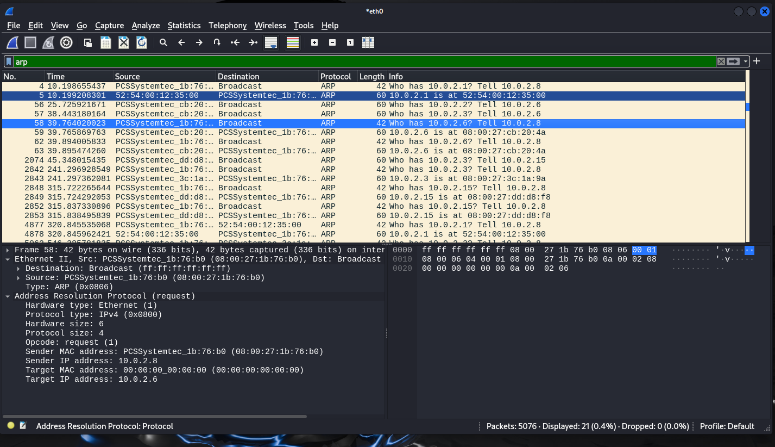

ARP routing of IP address to MAC address, IPv4 protocol used, Sender & Target IP/MAC address

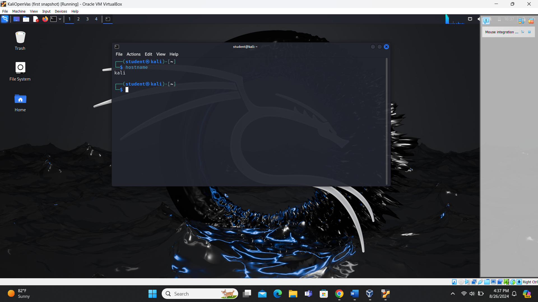

Host Device Name

**4. Information Collection Methodology**

**Tools Used**

* **Nmap**: For network scanning and device information collection.
* **Wireshark**: For capturing and analyzing network traffic.

**Steps Taken**

1. **Initial Setup**:
   * All virtual machines (Windows11, Linux Server, and Kali OpenVAS) were turned on and connected to the network.
   * Wireshark was started on the Kali OpenVas VM to capture traffic on Ethernet0.
2. **Network Scanning**:
   * **Nmap/Zenmap**: Used to perform intense scans on the network to discover devices and collect detailed information.
     + Command used: nmap -A 10.0.2.6 10.0.2.15 10.0.2.8
   * **Zenmap GUI**: Provided a user-friendly interface for setting up and running scans.
3. **Data Verification**:
   * Information collected via Nmap was verified by accessing each device and using commands like ipconfig /all, hostname, systeminfo, and netstat -an on Windows, and ifconfig, hostname, uname -a, and netstat -tuln on Linux.
4. **Traffic Analysis**:
   * Wireshark captures were analyzed to verify network traffic details and ensure accuracy of the collected data.

**5. Network Topology Diagram and Segmentation Recommendations**

**Network Topology Diagram**

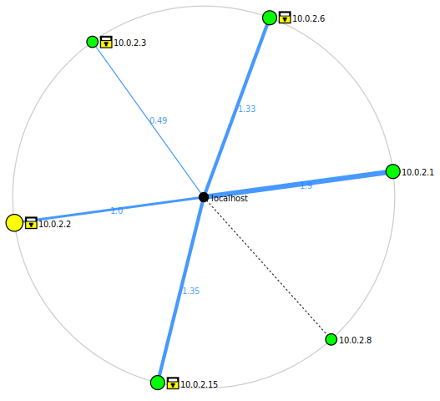

**Segmentation Recommendations**

* **IP Address Ranges**:
* **Segmentation**: By assigning different IP address ranges to various segments of your network (e.g., servers, workstations, guest devices), you can isolate traffic. This limits the spread of potential threats and makes it easier to manage and monitor network traffic.
* **Access Control**: Different IP ranges allow you to apply specific firewall rules and access controls tailored to each segment. For example, you can restrict sensitive server access to only certain IP ranges, reducing the risk of unauthorized access.
* **Traffic Analysis**: Segmented IP ranges make it easier to analyze traffic patterns and detect anomalies. If a segment that should only have internal traffic suddenly shows external connections, it can be a red flag for potential security issues.
* **VLANs (Virtual Local Area Networks) :**
* **Isolation**: VLANs allow you to logically separate network traffic even if devices are on the same physical network. This isolation helps contain potential threats within a VLAN, preventing them from spreading to other parts of the network.
* **Service-Based Segmentation**: You can create VLANs based on the services running on each machine. For example, separate VLANs for web servers, database servers, and user workstations. This segmentation ensures that only necessary traffic is allowed between VLANs, reducing the attack surface.
* **Enhanced Security Policies**: VLANs enable you to apply specific security policies to different segments. For instance, you can enforce stricter security measures on VLANs hosting sensitive data compared to those used for general internet access.
* **Improved Manageability**: VLANs simplify network management by grouping devices with similar security requirements. This makes it easier to implement and maintain security policies, monitor traffic, and troubleshoot issues.
* **Use HTTPS**: Ensure that the web server is configured to use HTTPS instead of HTTP. This encrypts the data transmitted between the server and clients, protecting it from eavesdropping and tampering.
* **Update Software**: Regularly update the web server software (e.g., Apache, Nginx) and any web applications to the latest versions to patch known vulnerabilities.
* **Firewall Rules**: Configure firewall rules to restrict access to port 80. Only allow trusted IP addresses if possible, or redirect HTTP traffic to HTTPS.
* **Web Application Firewall (WAF)**: Implement a WAF to filter and monitor HTTP traffic to and from the web application, protecting against common web exploits like SQL injection and cross-site scripting (XSS).
* **Disable Unnecessary Services**: Ensure that only necessary services are running on the server. Disable or remove any services that are not required.
* **Use Strong Authentication**: Ensure that strong, unique passwords are used for all MySQL accounts. Avoid using default or easily guessable passwords.
* **Restrict Access**: Limit access to the MySQL server by configuring it to listen only on localhost or specific IP addresses that require access. Use firewall rules to restrict access to port 3306 to trusted IP addresses only.
* **Enable SSL/TLS**: Configure MySQL to use SSL/TLS for encrypting data in transit. This prevents eavesdropping and man-in-the-middle attacks.
* **Regular Updates**: Keep MySQL and its dependencies up to date with the latest security patches and updates to protect against known vulnerabilities.
* **Database Permissions**: Grant the minimum necessary permissions to MySQL users. Follow the principle of least privilege to limit the potential damage from compromised accounts.
* **Disable Remote Root Access**: Ensure that the root account cannot be accessed remotely. Use a dedicated administrative account for remote management with limited privileges.
* **Monitor and Log**: Enable logging and regularly monitor MySQL logs for any suspicious activity. Tools like MySQL Enterprise Monitor can help in tracking and analyzing database activity.
* **Backup and Recovery**: Regularly back up your databases and ensure that you have a tested recovery plan in place. This helps in quickly restoring data in case of a security incident.
* **Use a Web Application Firewall (WAF)**: If the MySQL server is part of a web application, consider using a WAF to protect against SQL injection and other web-based attacks.

**6. References and Citation**

* **Nmap Documentation**: *NMAP Documentation - free security scanner for network exploration & security audits*. (n.d.). https://nmap.org/docs.html
* **Wireshark Documentation**: *Wireshark · Documentation*. (n.d.). Wireshark. https://www.wireshark.org/docs/
* **VirtualBox Documentation**: *Documentation – Oracle VM VirtualBox*. (n.d.). <https://www.virtualbox.org/wiki/Documentation>
* Microsoft. (2024). *Microsoft Copilot* [AI-based conversational assistant]. Microsoft Corporation